RMYC Attend 2019 Canada We Want Conference
Submitted by Yamaan Alsumadi & Heran Zhao, RMYC Co-Presidents
By NetNewsLedger March 26, 2019

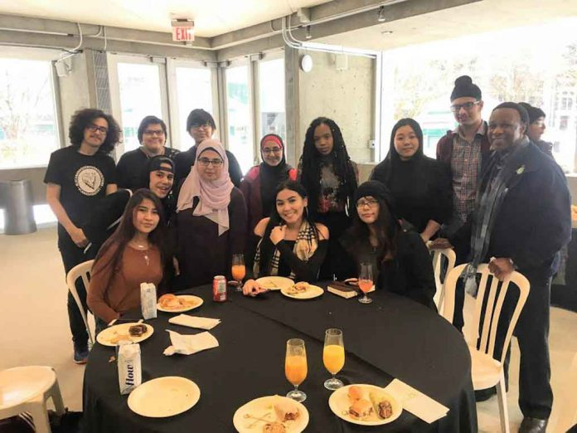
Members of the Regional Multicultural Youth Council attending the 2019 Canada We Want Conference pose for picture at the Roy Thomson Hall in Toronto before group presentations to M.P. Peter Schiefke, Parliamentary Secretary for Youth in Prime Minister Justin Trudeau’s office, and other dignitaries.

THUNDER BAY – The Regional Multicultural Youth Council (RMYC) sent 13 delegates to the 2019 Canada We Want Conference in Toronto from February 22 to March 1. The event hosted by the Students Commission of Canada brought together over 150 youths and adult allies from every province and territory. We engaged in discussions through four lenses: Truth and Reconciliation, Addressing Structural Racism, Children’s Rights, and Social Inclusion for Children and Youth Living in Rural, Remote and Northern Communities.
There were nine interactive workshops on Education and Employment, The Justice System, Addressing Substance Misuse, The new Canada Food Guide, The Environment & Chemical Management, Healthy Close Relationships, Social Identify Formation, Sharing Stories via Social Media, and The Canada We Want Leadership Movement.
The sessions provided the youth with opportunities to talk about the situation in their communities, listen to each other’s stories and discuss problems. Even though we were from different parts of Canada, we faced similar issues and were challenged to find solutions. The goal was to create a vision of “The Canada We Want” and come up with strategies to make this happen.
All delegates were inspired to share what transpired at the conference and develop ways to make a difference. The RMYC is working to create the ‘Thunder Bay We Want’ that is more welcoming, inclusive and prosperous. Since coming back the youth council has been meeting every Saturday afternoon at 3:30 p.m. to implement our plan of action. We are committed to reconciliation, improving race relations, inclusion, equity, and making our schools and neighbourhoods safer.
We made and distributed thousands of multicultural/multicoloured bows of black, red, yellow and white ribbons intertwined representing the beauty of the human race united in harmony to commemorate March 21, the International Day for the Elimination of Racial Discrimination.

We helped to plan and organize the Youth Suicide Awareness Walk from City Hall to the Canadian Lakehead Exhibition on March 22. We are collaborating with Diversity Thunder Bay, school boards and various Indigenous groups to host “Coming Together to Talk with Youth–a Community Conversation for Hope” at Lakehead University on April 30 for over 300 high school students. We will also be actively promoting ‘Celebrate Canada’ events that bring our community together beginning with National Indigenous People’s Day-June 21, Saint Jean Baptiste Day-June 24, Canadian Multiculturalism Day-June 27, and end with Canada Day-July 1. More activities and events are posted on our website: http://my.tbaytel.net/manwoyc
The RMYC uses a youth-to-youth approach and positive peer influence to engage children and youth in proactive activities and prevention ideas that help to break negative cycles. With 89% of young offenders in federal correctional institutions having below grade 10 education, supporting youths to stay in school and graduate or learn a trade will reduce crime and poverty rates, increase employment prospects and incomes, and improve the standard of living and quality of life.
We are appealing to service providers and adult allies passionate about helping young people to lend a hand and provide guidance. As a dependent population with no financial capital, we need community leaders and potential sponsors to support youth-led activities as investment into an inclusive and diverse Thunder Bay where everyone feels accepted, respected, safe and treated fairly. By working together we can build a safer prosperous multicultural ‘Canada We Want’ for present and future generations.
Anyone interested to be part of our ‘Thunder Bay We Want’ campaign can contact the RMYC at the Multicultural Youth Centre, 511 E. Victoria Avenue, Tel: 622-4666, or via e-mail at rmyc.help@gmail.com

