

**VOICES OF YOUTH PROJECT FOLLOW-UP**

**Youth Empowerment through Education**

*Highlights from the RMYC 2024 Summer Pilot Project to hire and train First Nations students as Peer Mentors/Student Ambassadors to work in their communities with children and youth, inspire, motivate, and support them to get credits to graduate and complete their education. The aim was to develop local young leaders as role models with the capacity and skills to engage their peers to be part of the solution to the problems they are facing, work together with stakeholders to empower themselves to stop negative cycles and encourage each other to adopt healthy lifestyles, stay in school for good paying jobs to improve their lives, and transform their communities.*

***Prepared by:***

The Regional Multicultural Youth Council (RMYC)

Multicultural Youth Centre

511 E. Victoria Avenue

Thunder Bay, Ontario

P7C 1A8

Tel: 807 622 4666 Fax: 807 622 7271

**January, 2025**

**2**

**TABLE OF CONTENTS**

1. Scope of the Summer Pilot Project to Engage Students 3

2. Observations 5

3. Peer Mentoring for Student Success and Change in Communities 6

4. The Summer School Initiative 8

5. Concluding Comments and Recommendations 10

6. Peer Leader/Mentor & Student Ambassador Training Resources 15

* Talking Guide for Students Leaving Home for School in Urban Centres 15
* Talking with Students Who Dropped Out or Were Sent Home 16
* Talking with Parents Sending Students Away to School 17

7. Welcoming First Nations Students to Thunder Bay 18

8. RMYC Peer Mentors: Students Helping and Supporting Each Other 19

9. DFC Student Ambassador and Peer Mentoring Program 20

10. Nishnawbe Aski Nation Chiefs-in-Assembly Resolution 21

11. The Project Team 23

12. Acknowledgements 23

3

**PEER MENTORS SUPPORTING INDIGENOUS STUDENTS TO GRADUATE**

**Scope of the Youth-led Project Summer Project:**

A recommendation from the Voices of Youth 2023 Project undertaken by the Regional Multicultural Youth Council (RMYC and the Nishawbe Aski Nation (NAN) Oshkaastisak (All-Youth) Council to re-engage First Nations students post the COVID-19 pandemic called for expanding the peer mentoring initiative started by the RMYC to engage and empower First Nations students in the city to survive, thrive, and succeed.

After the Seven Youth Inquest into the deaths of Indigenous students from remote First Nations communities while they were attending school in Thunder Bay, the RMYC initiated a Peer Mentor/Student Ambassador Program at Dennis Franklin Cromarty (DFC) High School. We identified role model students and trained them to involve their peers in activities to enhance student safety, wellness and achievement. They helped to plan and organize extra-curricular activities to alleviate boredom and loneliness, adapt to city life, motivate them to attend school and support them to achieve their academic goals.

The Voices of Youth Project confirmed that the pandemic had an adverse impact on student learning. Intervention was needed to re-engage them in the education system, and reduce the high numbers of school dropouts. Hence the need to build on the success of the peer mentoring initiative and expand it beyond DFC High School to reach First Nations students while in their communities before they leave home to attend school in the city.

We received funding from the Laidlaw Foundation, NAN and Indigenous Services Canada and hired Student Ambassadors as Peer Mentors to work in their communities over the summer. They were to talk with youths and their parents about leaving home for school in urban centres. Thunder Bay is surrounded by 90 First Nation in three Treaty Areas and we faced a challenge of choosing communities to host the pilot project. However, our partnership with Oshkaatisak, and NAN’s financial contribution simplified the matter because more than half of the First Nations (49) in the region are in NAN territory and a majority send students to Thunder Bay high schools and post-secondary institutions.

4

The proposal was to hire 5 students to work in five communities over the summer holiday. Taking into consideration the number of First Nations involved, we increased the sample to 11 communities and hired 20 student peer mentors. We selected the following First Nations: Aroland, Deer Lake, Eabametoong, Kasabonika Lake, Nabinamik, Neskantaga, Round Lake, Sachigo Lake, Sandy Lake, Webequie and Whitesand that had Student Ambassadors involved with the RMYC. To cut costs, the students worked part time, and liaised with local education authorities, Choose Life and Jordan’s Principle workers.

We coached the Peer Mentors/Student Ambassadors to talk about studying in a large city, living in boarding homes with strangers, loneliness, homesickness, using the transit system, and so forth. Since they were attending or had attended school in Thunder Bay, they were familiar with the services and supports for First Nations students in schools, the extra-curricular activities, cultural events students can attend, and volunteer opportunities to earn community hours the need to graduate. They reached out to students planning to leave home for school and provided orientation for culture shock to prepare them for life in the city. They also had to engage parents and care-givers to promote the resources and supports available for the children to ease their fears and anxiety over their safety and wellbeing while studying away from home and their care. We wanted families/parents to be aware of services available in the city and feel comfortable sending students away.

Peer Mentors in Eabametoong, Round Lake, Sachigo Lake, Sandy Lake and Whitesand were based in the community and had direct contact with students planning to leave home for school and their respective parents. For Aroland, Deer Lake, Kasabonika Lake, Neskantaga, Nibinamik, and Webequie contact was hybrid -- on-line and through other current and past students at home. In Sandy Lake and Round Lake, the students used local schools for meetings to talk about their experiences studying in Thunder Bay. They shared personal stories about what they went through, culture shock and how they endured the transition from a reserve to a large urban centre. There were field trips to Deer Lake, Eabametoong, Nibinamik, Webequie and Whitesand to support the Peer Mentors, see how they were working, and gather feedback from the students and parents they were meeting with. The RMYC supervised and monitored the team’s performance.

5

**Observations:**

The strategy to have local students who are survivors in the city mentoring their peers and sharing stories about safety, wellness, academic success, post secondary education, career goals and so forth was intended to inspire them to follow in their footsteps. We are aware of the traumatic experiences Indigenous peoples had in residential schools and the resentment they have about sending their children away for school. Memories of how they were treated were triggered by the Truth and Reconciliation Commission consultations. The RMYC also heard stories about mistreatment in residential schools and the fears of losing children during the Seven Youth Inquest into the deaths of First Nations students sent to school in Thunder Bay when we worked on the Voices of Youth 2023 Project.

These concerns are genuine and have to be addressed to improve student retention and increase graduation rates of Indigenous youths. We have to acknowledge the raw feelings and pain that exist in First Nations communities and among families and parents. New strategies and approaches are required to engage them in dialogue to change attitudes and negative perceptions about education. Parents on reserves where the school dropout rates are highest need motivation to encourage children to attend school regularly.

A report published in the Toronto Star on May 14, 2014 revealed that the number of Aboriginal youth dropping out of high school had improved somewhat from 48% to 41%. However, this number is still appalling when compared to the overall Canadian dropout rate of 10%. The report goes on to say that on reserves, the dropout rate was 58%, and achievement in the Prairies and Northwestern Ontario was generally worse than the national average. .

The school drop-out rate among First Nations youth in our region was already very high before the pandemic. A report by Dr. John Hogson and Nadine Hedican: “Educational Challenges for First Nation Children in Thunder Bay Schools – Let the Dreaming Begin”, revealed that Indigenous students have a startlingly high dropout rate of eighty per cent (80%). What we heard from youths who participated in the Voices of Youth Project, confirms that the pandemic will make the existing situation worse.

6

According to Statistics Canada and Correctional Service Canada more than 80% of young offenders in the federal correctional system have below grade 10 education and 65% have less than grade 8. The facts are: One in ten school dropouts between the ages of 16 to 24 are either in prison or in juvenile detention. 98% of girls in Saskatchewan youth jails were Indigenous. Upwards of 70% of inmates is Manitoba jails were Indigenous. 50% of all women in federal are now Indigenous despite Indigenous women making only 2% of Canada’s female population.

There is a direct correlation between a lack of high school education and incarceration. The preceding information confirms whythere is the over-representation of Indigenous youths in the criminal justice system and jails**.** Unfortunately,these numbers are not improving as recent reports reveal that 98% of girls in Saskatchewan youth jails were Indigenous. Upwards of 70% of inmates is Manitoba jails and 80 to 90% in northwestern Ontario provincial prisons were Indigenous.

At a press conference in Ottawa on November 2, 2023, Correctional Investigator Dr. Ivan Zinger acknowledged that Canadian prisons were disturbingly and unconsciously Indigenized and the problem is getting worse. He referred to the disproportionate and growing number of Indigenous individuals behind bars as among Canada's most pressing human rights issues. He went on to say that 50% of all women in federal prisons are now Indigenous despite Indigenous women making only 2% of Canada’s female population. In 2013, this number was 25% and in 2018 it had risen to 43%. A majority of women offenders are survivors of physical and sexual abuse and trauma.

In this context, the RMYC and Oskaatisak Council believe that a good education will stop this cycle. It opens doors to more employment opportunities which is an effective strategy to alleviate poverty and misery, enhance our safety by reducing crime, homelessness and addictions, and give youths a sense of purpose. More Indigenous youths graduating will transform their lives, families and communities. There is need to inspire and motivate Indigenous children in the home that going to school and graduating is the best way to assure them that things will change and give them hope for a better future.

7

The summer project empowered Indigenous youths to be directly involved in helping each other to do well in the education system. Student Ambassadors promoted access to higher education away from home and raised awareness of what is being done by the education authorities and schools to ensure their safety, wellness and success. We informed students and parents that this is no longer the residential school era – things are different now and there are more resources and supports for First Nations students in schools. First Nations leaders and Band Councils should recruit successful local youths as role models who lead by example and use peer influence to engage children in learning, and advocate for initiatives that enhance student wellbeing, safety and achievement on and off reserves.

**Peer Mentoring for student success and change in communities:**

When schools opened in the fall, we wanted the Peer Mentors/Student Ambassadors to stay connected with the students they worked with in their communities and build on the relationships they had developed. We wanted to foster the trust established between them and their parents and reassure families that their children were not alone.

We felt that students needed on-going support and guidance from someone they knew after working together at home, could approach when facing problems, ask questions, discuss issues and learn about life in the city. We saw this is an effective strategy to alleviate anxiety and stress, address loneliness and fears of the unknown, as well as build confidence among students leaving home to study in a new place.

So far, the Peer Mentors/Student Ambassadors have been there to check on the wellbeing of their peers, encourage them to attend classes, help them with school work, remind them to stay safe in the city, and motivate them to achieve more than they think they can. They are inspiring other students to realize their potential, set goals to stay in school, work hard and get all the help they need to graduate and become role models for success to stop the cycle of the current high attrition among Indigenous children and youth. We believe that peer support and positive influence will have remarkable ripple effects by inspiring children and youth make new beginnings. They have inherited the legacy of residential schools and trauma that continues to exist unless the youth are empowered to make a difference.

8

With the summer pilot project over, we now need funding to maintain support for the Peer Mentors/Student Ambassadors to continue working with students throughout the school year. We wanted them to monitor student attendance at school, follow-up with those who miss classes, chat with individual students about their challenges and hold focus groups on school work, assignments, tutoring and so forth. They would also discuss wellness, mental health, addictions, counselling, home-sickness, loneliness, boarding homes, racism and other topics of interest. We believe that involving the youth to help each other will develop their skills, capacity and confidence to work together in the city and at home.

The RMYC runs the After School Program at DFC and the Peer Mentors/Student Ambassadors are involving their peers to plan and organize extra-curricular activities they enjoy to keep busy, alleviate boredom and home sickness and provide opportunities to volunteer and earn community hours to graduate. They are promoting study groups and tutoring sessions for academic success and events to share culture and socialize. We want all students to feel they belong, be proud of their identity and advance racial harmony to combat discrimination and enhance reconciliation. There is training to develop skills and capacity for students to work with peers at school and when they go back to their reserves.

This project complemented the Seven Youth Inquest recommendations to create peer mentors among students, prepare First Nations students who leave home to attend school in urban centres and link them with supports to succeed, and work with other partners to enhance student safety, wellness and achievement. The RMYC gives youth a voice and believes that youth-led projects provide opportunities to implement proactive strategies from a youth perspective they easily buy into because there is no generation gap.

Education is the passport to a higher standard of living and a better quality of life, and will reduce the socio-economic inequality between Indigenous people and non-Indigenous Canadians. More opportunities for indigenous students to learn will teach them critical thinking and problem solving skills. Introducing summer school on First Nations reserves will add chances for them to get diplomas and increase their chances of pursuing careers and being employed to do jobs they would not be qualified to do without a diploma.

9

**The Summer School Initiative:**

The students we interviewed overwhelmingly felt that summer school will enable those who did not get credits when schools were closed during the pandemic to catch up. They suggested a class-like setting with a supervisor watching over students to make sure they show up and do their schoolwork. Studying from home had many distractions and technological problems such as unreliable internet access. Family issues, absenteeism due a lack of motivation or parental encouragement to attend school and procrastination to do school work disengaged youths from learning. Summer school with the dedicated support of peer mentors familiar with the community will make a difference.

A designated class room for summer school will help students to focus and stay on track with their school work. Providing guidelines for safe use of the internet will enable students to manage their time, avoid distractions and problems such on-line gaming, gambling, cyber-bulling, pornography and so forth. Incentives such as food and snacks as well as awards, prizes and fun games will attract students to attend summer classes regularly.

Summer school can be different from community to community and should complement local resources, values and traditions. Students failing courses or needing extra help to improve literacy and numeracy skills and those who missed classes are ideal candidates for summer school. A safe space such as a school, community centre or church that is accessible to the youth, and reliable adult volunteers to supervise the facility and the students are priorities. Classes can run a few hours a day on alternate days of the week. Afternoon classes can begin with lunch (students can help to prepare) and last a couple of hours. Evening classes with supper are an option for cooler weather on hot days.

Older students in senior grades or attending post-secondary institutions can be hired as peer mentors and role models to inspire the youth to appreciate learning and follow in their footsteps. Hiring local students to run summer school is cheaper as they can be funded under summer jobs and work-experience programs. They should be trained as class supervisors and groomed to work as chaperons, mentors and tutors helping, guiding and coaching their peers to show up, behave, solve problems and complete assignments.

10

Familiar faces who understand social conditions on reserves mentoring and supporting students and asking parents/care-givers, Choose Life and Jordan’s Principle workers for assistance to encourage children to go to school will improve attendance and success rates. Local education authorities can work with Keewatinook Internet High School, Wahsa Distance Education, and other publicly funded school boards for students to earn summer course credits. Band Councils should discuss job priorities and employment opportunities on reserves, and invite guidance counsellors, professionals and skilled trades people for advice on job trends, new technology, careers and professions for future employment prospects.

Learning in summer is a strategy to narrow the academic performance gap between on-reserve and off-reserve students which is acknowledged as contributing to the high dropout rate when they move to urban schools. Summer school provides structured activities and time management for youths without jobs during the holidays. This will reduce boredom and the risk of delinquency, juvenile truancy, addiction and crime.

A Statistics Canada report released by Jaclyn Layton on June 21, 2023 reveals that just under two-thirds (63%) of all First Nations youth had completed high school, compared with 91% of the non-Indigenous population. First Nations youth living off reserve were more likely to obtain their high school diploma (73%) than First Nations youth living on reserve (46%). Increasing student graduation will go a long way to reducing the over-representation of Indigenous people in the justice system and in prisons.

According to Statistics Canada and a recent study by Ian Cameron of The University of British Columbia, the crime rate in Indigenous communities is six times as high as in non-Indigenous communities. A majority of the offences are mostly due to mischief, common assault and disturbing the peace, largely due to alcohol. Young aboriginals are more likely to be heavy drinkers**,** and are more affected by alcohol than are non-Indigenous youths. In reserves with over-crowded houses, rowdy behaviour stands out more than in larger communities with more and better housing. Issues of alcohol and substance misuse are eye-sores and result in bad behaviours that disrupt peace and threaten our security. This generates fears and apprehensions that reinforce stereotypes and hinder reconciliation.

11

Deplorable living conditions and the Third World-like socio-economic climate due to colonization and residential schools exacerbate trauma, which leads to indulgence in alcohol and substance abuse, crime, mental health issues, suicide and so forth. Summer school can be a catalyst that brings together Peer Mentors working with students to get academic credits, and programs such as Choose Life, Jordan’s Principle and Tikanagan to use the school setting for presentations about their work and lead discussions about problems in the community, the help and resources available and what the youth can do to live a safer and healthier life.

Summer school should include academic excellence, personal growth knowledge, and character development children and youth need to be successful on and off reserves. Students cannot concentrate on learning and do well in school when safety issues, bullying, hunger, addictions and other problems are distracting their attention. Hence the need to involve social service agencies in summer school.

**Concluding Comments and Recommendations:**

The RMYC is working with the NAN Oshkaatisak Council to form youth groups/councils on reserves and support them to initiate change they want to see for a better future. Youths must be involved in shaping their destiny and need education for gainful employment and socio-economic development in their communities. We can provide on-going training to create young leaders and build resilient Peer Mentors/Student Ambassadors as role models who work with students in the city, and engage children and youth on reserves to stay in school and develop the capacity to deal with the challenges in their lives.

We have to do things differently to get better results. Reducing school dropouts and supporting youths to get a good education for good jobs will reduce the current high incarceration rates. Young offenders and parolees with high school diplomas have greater chances of getting jobs and breaking the cycle of poverty, addictions, crime, human trafficking, gangs, homelessness which changes the narratives about what people see on the streets, and negative attitudes that contribute to prejudice and Anti-Indigenous racism.

12

Indigenous groups cannot do this alone. They did not create the political structures and systems we are operating under. They are victims of racist policies that have marginalized them and perpetuate lifestyles that continue to worsen their quality of life and lower life expectancy. The Truth and Reconciliation Commission’s 10 principles of reconciliation, the 94 Calls to Action, and the 46 articles of the United Nations Declaration on the Rights of Indigenous Peoples are instruments of reconciliation that should be taken by all sectors of Canadian society as the framework and blueprints for moving forward.

The RMYC founding-president, Melanie Goodchild, a high school student from Pic River First Nation wanted indigenous and non-Indigenous youths to work together, learn to get along and support each other. She was aware of the struggles of Indigenous youths in the education system and that many were dropping out of school and ending up in a cycle of unemployment, poverty, incarceration and despair, contributing to mental health issues, addictions, violence and high youth suicide rates. To respond, the RMYC initiated inclusive proactive programs supporting First Nations students that have been acknowledged by Nishnawbe Aski Nation Chiefs-in-Assembly who passed a unanimous resolution endorsing and supporting financially the work of the multicultural youth council.

The First Nations leaders’ approval and financial contribution to the RMYC’s youth-to-youth approach to help Indigenous students adjust to urban schools and city life validated the value of the youth council’s involvement to facilitate their integration and success in our multicultural society. Non-First Nations students taking the initiative to work with and help First Nations students changes attitudes and forges positive relationships that build understanding and friendships for better race relations and our collective prosperity.

The RMYC’s experience confirms that inclusive activities and programs where children and youth are exposed to diverse cultures, ethnicities and skin-colours in a collaborative nurturing environment reduces cultural and racial stereotypes. Diverse students sharing stories learn objective perspectives on culture, up-bringing, and lifestyles. Encouraging and supporting non-Indigenous and Indigenous youths to interact in a safe space and respectful climate is an effective way to combat prejudice and racial discrimination.

13

Thunder Bay has the potential for playing a key role in the development of First Nations communities. With eight high-schools (three of them run by Indigenous groups) DFC, Matawa Education and Care Centre and Seventh Fire Junior High & Secondary School), as well as three major post secondary institutions (Confederation College, Lakehead University and Oshki Wenjack Education Institute), the city is the regional centre for higher learning, skills training and socio-economic development. This is a very powerful and enviable position to transform the region by supporting Indigenous students to get the education and skills they need to participate equally in all sectors of Canadian society.

We are aware of the abundant natural resources on First Nations traditional lands across this vast region that covers two thirds of Ontario’s land-mass. Indigenous peoples have long complained about the exploitation of resources and raw materials without fair compensation and economic benefits. We feel that objections, resentment and tensions will be greatly reduced if there were many well educated First Nations people qualified for employment in senior management jobs and administrative positions with an inside voice to guide the natural resource industries, make culturally appropriate decisions for the extraction of the resources and set the terms for the best financial returns.

The City of Thunder Bay should act accordingly to earn the trust of First Nations that the community welcomes Indigenous students, their lives matter, ensures their safety, and supports them to succeed. In the joint Voices of Youth 2023 Project with the Oshkaatisak Council that won the Mayor’s Outstanding Community Project Award, the RMYC made recommendations to improve relations with Indigenous groups. This included working with stakeholders to implement the Seven Youth Inquest recommendations, funding the RMYC’s Student Ambassador/Peer Mentor Program, filling the position of Thunder Bay Child Advocate to give youth a voice at City Hall, and creating safer spaces for students.

The RMYC submitted a proposal to undertake activities to follow-up on the success of the award winning project. We were surprised that the project was denied funding by the City, thereby disrupting the momentum for action and the anticipation of re-engaging First Nations students impacted by the pandemic and supporting them to get their diplomas.

14

Youth are a dependent population with no financial capital to fund their activities and support their projects. They rely on adults, benevolent donors and all levels of government for resources to be actively involved in programs that help to shape their destiny and determine their future. The RMYC has been in existence since the United Nations International Youth Year in 1985. For 40 years, we have seen how a lack of adequate and stable funding for sustained youth engagement is a major barrier for youth-led initiatives to be effective and successful. Existing funding systems have not supported youth-led projects for significant upward mobility of Indigenous, racialized, marginalized, and minority youths. Only a few fortunate ones are able to move up the ladder and prosper.

From years of experience, frustration and disappointment the RMYC wants Thunder Bay to do more and support First Nations students coming to the city for higher education to succeed. We need to create a wider pool of well educated Indigenous people as role models for more to follow in their foot-steps. Therefore, the City and other levels of government should reciprocate NAN’s resolution supporting the RMYC and work with the youth council to build on proactive initiatives already approved by First Nations leaders.

Band Councils impacted by crises and tragedies involving their children and youth should introduce the summer school initiative and hire students to work in leadership roles as Peer Mentors focusing on success in education, job training and discussing the challenges children and youth are dealing with to enhance their wellness, safety and success. The RMYC and Oshkatisak Council can train young leaders and support them to empower children and youth to have hope for a better future, encourage them to have a vision of what they want to be and see in their communities, set goals and help them to find the resources to take action and create new beginnings in their lives and communities.

It is critical to involve children and youth to make them feel they belong and have a sense of purpose. Progress is being made in some areas, but old systems and policies need to change to accelerate development. Our main recommendations are to invest upstream in education and train young leaders as Peer Mentors/Student Ambassadors as role models who use positive peer influence to make a difference.

15



511 E. Victoria Avenue, Thunder Bay, Ontario P7C 1A8 Tel: (807) 622-4666 Fax: (807) 622-7271

**A TALKING GUIDE FOR STUDENTS AND PARENTS ABOUT CITY LIFE**  *A guideline and job description for Student Ambassadors / Peer Mentors*

**Talking with students who will be leaving home for school:**

1. Contact the school in your community or anyone involved with education to find out which students will be leaving your community to attend school in Thunder Bay.

2. Tell them that you are working part-time for the Regional Multicultural Youth Council (RMYC) that runs the Multicultural Youth Centre (a safe place for all youths in Thunder Bay to hang out) and the After School Program at Dennis Franklin Cromarty (DCF) High School to talk with students who will be going away for school to better prepare them for a safe and enjoyable life in the city.

3. Get the names of the students, and begin arranging how you can talk with them, alone or in small groups. Link with Chose Life and Jordan’s Principle workers and plan together social events such as a barbecue or feast for all those leaving for school to socialize, know who is going away and bond. We will help to pay for it.

4. Find out which high school they will be going to in Thunder Bay i.e. DFC, Matawa Education and Care Centre or any other school. Keep this information for us.

5. Let the students know that you are being hired to work with First Nations students who will be leaving home to attend school in urban centres in the fall.

6. When you talk with the students, you can “break the ice” by sharing your personal experiences when you first left home to attend school in Thunder Bay, and you want them to know about feeling lonely, staying in a boarding home, homesickness, peer pressure, school work, using buses, racism, and so forth. Explain that you want them to be better prepared before leaving home for school in Thunder Bay.

16

7. Tell them how you dealt with lonely feelings when you missed home, what helped you to stay safe and out of trouble, and how you spend your time having fun in the city. Share with them what you would have wanted to know before leaving home about going away to school and living in a large urban centre!

8. Chat about what is available at DFC or MECC such as the After School Program, Elders’ Room, food, Gyms, Fitness Room, Sports & Games, Arts & Crafts, Music Room, Cultural room, Cooking room, and so forth to avoid boredom.

9. Feel free to share any personal goals and dreams – why education is important to you, why you are at DFC/MECC etc. and your plans after graduating i.e. personal career choices, trades that interest you or professional jobs you would like to do.

10. Ask students about their feelings and anxieties due to leaving home for high school, their fears, concerns and so forth. Encourage them to discuss with their parents any problems they feel about going to Thunder Bay for high school. End by asking the students if they have questions about living in the city. Thank them for giving you the opportunity to talk with them. Encourage them to contact you if they want more information about attending school and living in Thunder Bay.

**For students who dropped out or school or were sent home for failing their courses:**

Some questions you can ask students who were struggling at school and left are:

* Why did you drop out of school or why were you sent home?

* What help do you need to go back to schools and pass your courses?

* What on-going support do you need to stay focused and complete your education?

**For those sent home for “Risky behaviour”,** -- ask them if they will be returning to school in the fall? If they are going back, ask them what plans they have in place to avoid making the same mistakes repeating the same behavior and being sent back home again?

Encourage students to be involved in the After-School Program, participate in extra-curricular activities and take advantage of the supports available to be safe and graduate.

17

**TALKING WITH PARENTS SENDING STUDENTS AWAY TO SCHOOL**

* Contact the school in your community or the Education Authority to tell then what you are doing and ask for their help to identify parents/care-givers with children/ students who will be leaving the community to attend school in Thunder Bay.

* Begin by introducing yourself as a Student Ambassador/Peer Mentor hired by the Multicultural Youth Centre to work with boarding students. Tell them that you want to support students who will be leaving home to go away to school in the fall.

* Ask them their fears and concerns about having their children go away for school, their wishes, and any supports they want for their children to stay safe and succeed in city high schools.

* Tell them about the After School Program at DFC/MECC,etc and the supports, services and social activities available for their children in Thunder Bay.

* Talk about the extra-curricular activities at the school to keep students safe, busy, have fun, stay in school and get a good education.

Be polite, and thank the parents for their time. Let them know that as a Student Ambassador/Peer Mentor, you will help their children in the city. Encourage them to contact you if they have questions or want more information. Give them the RMYC contact information about our After School Program, Student Ambassadors and Peer Mentors.

**P.S.**

***Do you know that staying in school is the best way to a better, safer and healthier life? Promote graduating high school as the best strategy for youths to get a job, stay out of a life of criminal activities and having a criminal record! …. More that 80% of young offenders who go to jail have not completed their high school when they were arrested; 55% had not completed their grade 10, and 19% had completed less than grade 8.***

18

**WELCOMING FIRST NATION STUDENTS TO THUNDER BAY**

The Regional Multicultural Youth Council (RMYC) welcomes all First Nation students coming to attend school in the City of Thunder Bay. We are an inclusive youth-run group that works with students from different cultural and racial backgrounds. We organize activities to build friendships, help students to stay safe in the city, do well in school, graduate, and pursue their dreams. We also develop role models and encourage them to work with other students and use positive peer influence to make a difference.

The Youth Council runs the After-school program at Dennis Franklin Cromarty (DFC) First Nations High School. We use the gyms, library, fitness centre, the kitchen and other facilities in the school to create safe friendly spaces for Indigenous students to hang out. We provide free food and healthy snacks for anyone involved in our activities and arrange tutors to help students with school-work and assignments. Support is also available for those who need someone to talk with about loneliness, social and personal issues.

*The following are some of our activities all First Nations students can be involved in:*

* Meetings and workshops for students to discuss their interests and concerns
* Events for students to meet and mix with other youths from all backgrounds in the city and volunteer to earn Community Involvement Hours to graduate.
* Safer schools/safer community campaigns for students to feel safe in the city.
* Girl Power Program for girls/young women to have fun together, support each other, follow their passions and empower themselves to realize their dreams
* Band of Brothers for boys and young men to talk about manhood, relationships, responsibilities, risks, organize healthy activities, and have fun.
* Entertainment/recreation for excitement and physical exercise to promote wellness.
* Anti-Racism campaign to combat racism and all forms of discrimination. (Students can use our Racial Incident Reporting Form to record and file racist incidents)

Students attending DFC have Room #115 as a safe space to mix and socialize with RMYC members after school. Those attending other schools can come to our youth meetings on Saturday afternoons (2:00 p.m.) at the Multicultural Youth Centre, (511 Victoria Avenue, East – close to the Thunder Bay City Hall bus terminal). We want to hear your ideas on what we can do together to make your life safe and exciting in the city. We also provide training and support for students to plan and organize their own healthy activities.



19



511 E. Victoria Avenue, Thunder Bay, Ontario P7C 1A8 Tel: (807) 622-4666 Fax: (807) 622-7271

**RMYC PEER MENTORS -- STUDENTS HELPING AND SUPPORTING EACH OTHER**

The Regional Multicultural Youth Council (RMYC) Peer Leader / Peer Mentor Program trains youths to reach out and mentor their peers using positive influence. This involves developing skills to socialize and communicate with other young people to make sure they are Okay, feel safe, are not lonely, and are getting the help they need to thrive. We want to encourage students to access the supports available to stay in school, do well in their studies and graduate.

Working as a peer mentor involves being a role model and connecting with other students at school and at the Multicultural Youth Centre. This implies developing good relationships, understanding and respect. We want youths to feel they belong, not feel lonely or left out. To be acquainted and get the youth talking, smile and be polite. You can begin by asking a couple or so of the questions below to break the ice, and to show that you care!

1. How are you feeling today? What did you do last weekend -- I went to a youth meeting?

2. How is school going for you? or. What are your favourite subjects?

3. What are your hobbies and the things you enjoy doing for fun and to relax?

4. Are you caught up with your school work, or do you need help?

5. Are you aware of the services and supports available for students at school?

6. Are there any issues you are facing you want to talk to someone about?

7. What are your goals? -- Do you have the help you need to reach your goals?

8. Do you have a place to volunteer to get your community involvement hours?

9. What do you want to do after completing high school?

10. What social issues are you passionate about, or want to be involved in?

You can add other questions to train yourself to talk with shy and quiet students -- one at a time or in small groups, in the hallway, Cultural Room, etc. or at our Youth Centre. We want you to develop self-confidence and empathy to help your peers, become a leader and organize positive activities that will benefit other young people and make a difference in your life and theirs. Promote volunteering to alleviate boredom and contribute to the betterment of our community while learning work-skills and exploring areas of personal interest for potential career choices and contacts for references. Recruiting students to volunteer by attending RMYC activities and any events you plan with them will earn the Community Involvement Hours they need to graduate.

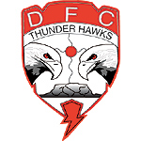 20 [](https://www.bing.com/images/search?q=RMYC+LOGO&id=084BD2028FA76F882CAD6AA385DF4502751C3F20&FORM=) **DENNIS FRANKLIN CROMARTY HIGH SCHOOL**

**STUDENT AMBASSADOR/PEER MENTORING PROGRAM**

**What is a Student Ambassador?**

Student Ambassador is a peer leader (mentor) serving as an advocate, spokesperson, liaison for students at Dennis Franklin Cromarty (DFC) High School. This means reaching out and connecting with students to hear their voices, listen to their concerns and interests and work with them to find solutions to issues they are facing. Student Ambassadors should be exemplary leaders and role models. They should share their life experiences and use positive influence to chance negative attitudes and bad habits to make a difference.

Student Ambassadors will be awarded volunteer hours or paid a fee to cover expenses, time, effort, skills and commitment to promoting student wellness, safety and graduation. They must develop good communication skills, show empathy and caring. They should be good listeners, be patient, and take time to learn and understand situations. Above all, Student Ambassadors must have a warm personality, positive attitude, be friendly and support their peers to realize their true learning potential, stay in school to achieve their goals and become the best they can be!

**Your Role as a Student Ambassador will include the following:**

* Approaching all students to let them know that you are there to help and support them.
* Encouraging students to speak up, and share any concerns they are having.
* Offering support and comfort to those feeling lonely and seem to be lost in the school.
* Helping students to seek and access the support they need to enjoy being at DFC.
* Linking with other Student Ambassadors to create a safety network for all students.
* Connecting students with the resources and services available at school and in the city.
* Involving students in the After-School Program and related extra-curricular activities.

**The Tasks you will perform are to:**

* Reach out and talk with students in hallways, at bus stops, play grounds, etc -- ask them if they are enjoying school, are involved in any extra-curricular activities, and if there is anything they need to make life at school and in the city enjoyable and fun.
* Talk with students about school, how their classes are going, their goals, and advise them of the tutoring services available, mental health counseling, the clinic, and so forth.
* Encourage students to plan and organize healthy activities they enjoy, encourage them to volunteer and to participate in functions at school and events in the community.
* Promote the After School Program & Room #115 Miinobaaziiwin Gaming–A Good Place as a safe place to hang out, relax, meet friends and mix with diverse RMYC members.

21

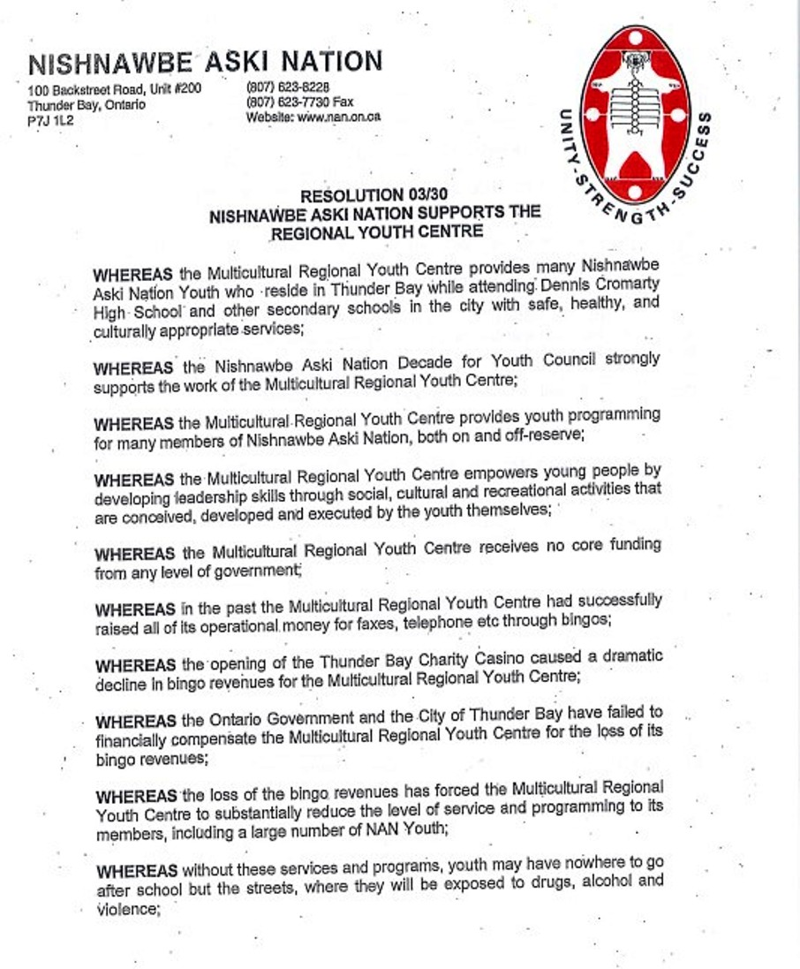

22

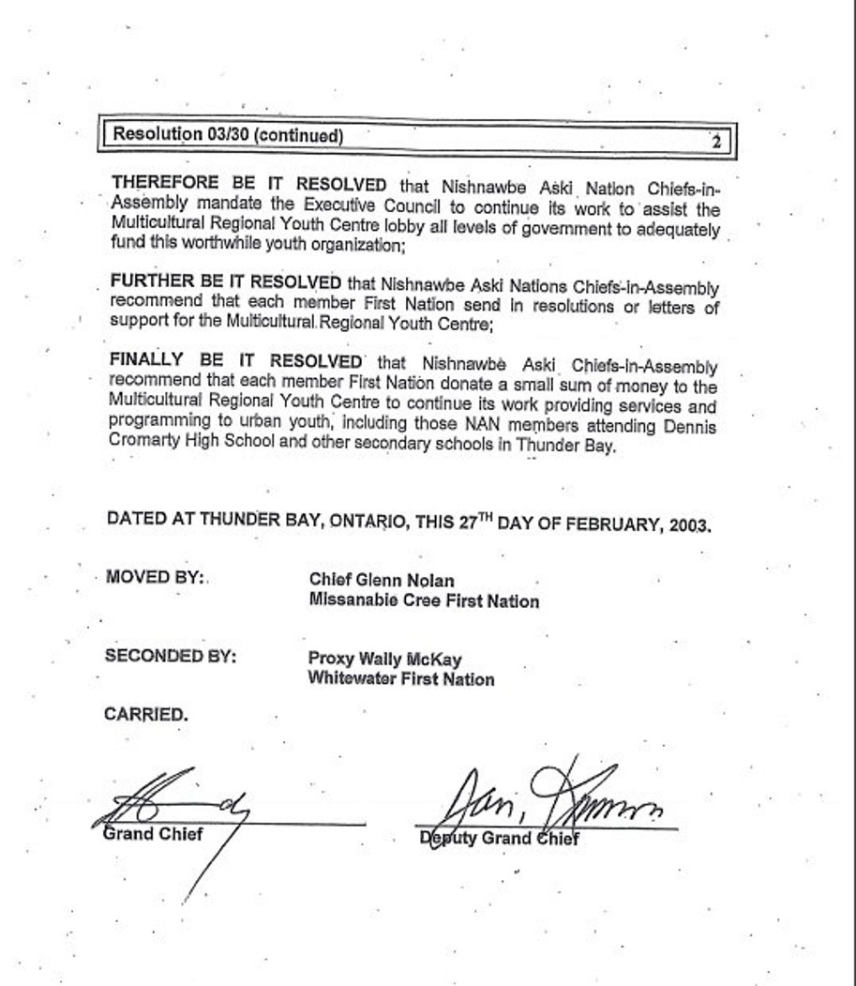

23

**ACKNOWLEDGEMENTS**

**Summer 2024 Project Sponsors:**

* The Laidlaw Foundation

* Nishnawbe Aski Nation

* Indigenous Services Canada

* Carleton University

* The Carrick Family (Food & Roots Clothing Incentives)

* Evelyn Shape (RMYC Summer School Program)

**PEER MENTORING PROJECT SUMMER TEAM**

**Project Co-ordinators:**

Kamryn Woloschuck, Tisha Duncan, Geogette Hamilton and Moffat Makuto

**Peer Mentors/Student Ambassadors First Nation**

1. Leo Agawa Aroland

2 Lael Rae & Summer Spade Deer Lake:

3. Kay Ostamas Eabametoong

4. Barren Semple & Emery Semple Kasabokika Lake

5. Alexis Sakanee Neskantaga

6. Jasper Beaver & Raya Beaver Nibinamik

7. Larissa Beardy, Jayda Jeremiah Round Lake & Cody Kanequanash

8. Myron Tait Sachigo Lake

9. Nolan Aysanabee, Maaca Kakepetum, Sandy Lake

Harmony Fiddler & Saffron Fiddler

10. Daryl Nodin & Lucas Sinoway Whitesand

11. Kiaya Nowegejick Webequie