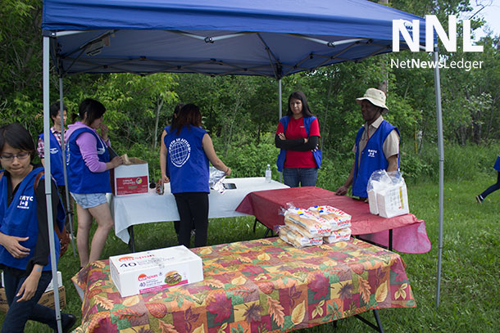
The Regional Multicultural Youth Council is getting set to feel lots of youth and neighbourhood residents. Moffat and his young people present a real benefit to the City of Thunder Bay
THUNDER BAY = LETTERS – The August/September issue of ”mytbay” has pictures of several members from the Regional Multicultural Youth Council (RMYC) urging young people to help shape the future of our city with the 2018 Municipal Election. We are appealing to all citizens to review the platforms of all the candidates and select those committed to enhancing the wellness, safety and success of children and youth with a vision to create a more accepting, inclusive and prosperous city for present and future generations.
The Thunder Bay we want is already outlined in Thunder Bay Children’s Charter adopted by City Council on June 14, 2004, to ensure that the beliefs and values enshrined in the United Nations Convention on the Rights of children are maintained at the municipal level in co-operation with other orders of government. Council Joe Virdiramo was selected as the Thunder Bay Children’s Advocate to promote the Children’s Charter. In 2014, just before in Coroner’s Inquest into the deaths of seven First Nations students attending school in the city, the RMYC requested a progress report from City Council for the 10 years the Thunder Bay Children’s Charter had been in existence. We wanted an update on the work of the Thunder Bay Children’s Advocate, and activities of the Thunder Bay Children’s Charter Coalition to advance the cause for children and youth.
We did not get any feedback until last December after Councillor Frank Pullia became the new Children’s Advocate. He shared with us the report he presented to City Council on December 18, 2017, which highlighted social issues affecting children and youth and the need for a more co-ordinated approach to close gaps and prevent more kids falling through the cracks. From our consultations with Councillor Pullia, we recommended that City Council should play a lead role in advancing it’s Children’s Charter, revive the Thunder Bay Children’s Coalition for a collective strategic approach to engage children and youth, and make it easier for youth-led/youth-focused groups such as the RMYC to access financial resources in order to be part of the solution to the problems we are facing. Several members from the youth council were present when Councillor Pullia’s motion in this regard was voted down by City Council, and the status-quo remains.
Action is needed to involve the youth, give them a voice and support them to be actively involved in creating the community they want to live in. There is a growing population of struggling families and damaged adults unfit to be positive role models. The Children’s Charter challenges us to take care of all children as a social investment for the betterment of our community.
Since many children are minors, we are appealing to all citizens old enough to vote to choose candidates who believe in the Thunder Bay Children’s Charter and will invest in programs, services and activities that will make a difference in the lives of marginalized groups, vulnerable kids and at-risk youths. “It is easier to build strong children than to repair broken men” – Frederick Douglass.
Yamaan Alsumadi, Benjamin Fedoruk, Aarianna Roberts and Heran Zhao, RMYC Executive Officers, Thunder Bay. October 15, 2018

